

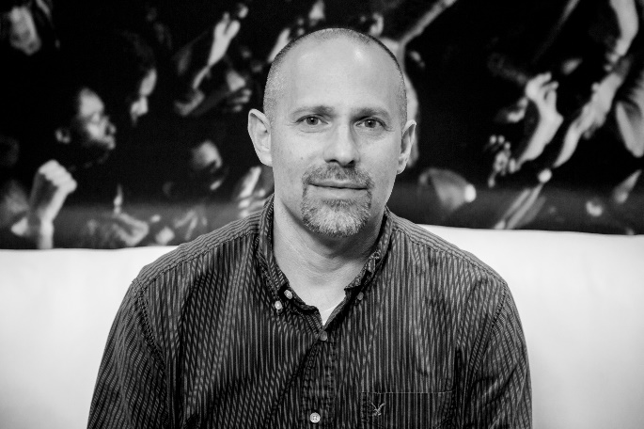**Come learn how**

**to be ALL-IN with**

**Duane Goodling**

**Location: ­­­­­** _________________________

**Date:** _________________________

**Time:** _________________________